MARK COLEY

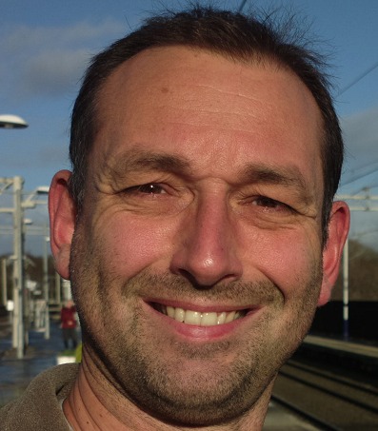

Experience:

MRCGP awarded August 2014. Worked as locum and salaried GP since qualification. Former physicist and researcher. Has worked in industry.

Statement to support my candidature:

My first degree was in physics followed by a doctorate in magnetic resonance imaging. Before and after university I worked in industry, in the nuclear and mobile telecoms sectors. Before graduate-entry medicine I worked for a year as an auxiliary nurse. I am principled and not afraid to take a stand. I have pulled the emergency stop on a Class 87 InterCity Train on the West Coast Mainline when an unsafe situation developed. I have also taken a stand, with the BMA, to deal with unsafe working practices during my training. Much behind-the-scenes work went on to try to improve the situation for other doctors across the country. Single-handedly I also succeeded in getting government agencies to admit to, and then eventually correct, a serious arithmetic error in the Doctors Rostering System which is used in many trusts to determine rota banding after monitoring exercises. It had been systematically undercalculating hours of work (and banding in some cases) for many years and it was only through the reverse engineering of the data it produced that I found the error. This required communication with Skills for Health, the GMC, HEE, NHS Protect, the ICO, the Department of Health and NHS Employers. The response from several of these was poor to say the least. I am keenly following @54kdoctors and witnessed their recent Employment Appeal Tribunal hearing. I follow GP Survival and Resilient GP and would wish to use my skills to help the work of the subcommittee should I be elected.

