Sessional GP Subcommittee Nomination Supporting Statement
Dr Siân Hartry
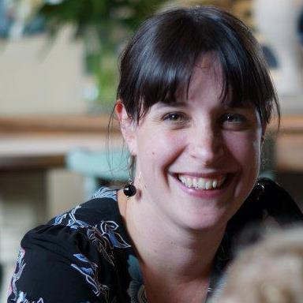
I currently work as a locum GP in Cheshire having moved from Sussex in 2014. I trained at Imperial College in London and qualified in 2005. My GP training was in Brighton and Hove and I now work throughout the Cheshire area.
I am an active member of 2 local sessional GP groups and am currently working with Primary Care Cheshire (the local GP federation) to set up a central ‘hub’ for locum and sessional doctors. I hope this will make locum life easier providing a single point of access for keeping up to date with local referral policies and forms, news, new salaried and partnership positions and a locum booking service free of charge to both the locums and practices who use it.
Since October of 2014 I have represented sessional GPs at West Cheshire CCG and find this work both rewarding and challenging. It has been a pleasure to provide a voice for the concerns of local sessional GPs and also to try and keep them up to date with local developments affecting general practice as a whole.
These are difficult times and I would be honoured to serve as a regional representative for the North West on the BMA Sessional GP subcommittee. I would dearly like to help address problems specific to sessional GPs such as the rapidly rising MDO fees and the threat of locum rate capping recently suggested by NHS England and alluded to (although not yet fully implemented) in the new GP contract.

