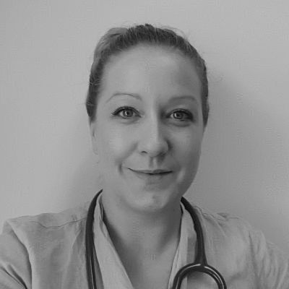 Dr Rebecca Jones – South East Coast GPC elections

As a newly qualified GP, I have to admit that I have little experience of committee work, but what I lack in experience I make up for with passion, enthusiasm, and a great sense of equality.
I am not frightened to stand up for what I believe is right, and when I feel that change is needed. As such, I am proud to say that I am one of the founding members of GP Survival, and stand on the steering committee as the representative for newly qualified and trainee GPs. I have set up a social media page for such members, and have kept abreast of issues affecting us younger GPs and those still in training.
I don’t shy away from making myself heard, and use my spare time to increase awareness of the plight of general practice, having been published in mainstream newspapers and many of the GP publications.
I feel that being in the early days of my career could be an advantage to sitting on the GPC, as I am entering general practice with a fresh pair of eyes at one of its most difficult times. I will offer the viewpoint of the younger GP, and can continue to represent that same group of newly qualified GPs working in a sessional capacity. I hope to gather opinions via the social media platform and ensure that they are carried forward and heard; for me this is particularly important for the new generation of GPs.
I want the voices of hardworking, grassroots GPs to be heard, to ensure the future of general practice is a safe, sustainable service which we can be proud to be a part of, and that young medics will still consider as a feasible career.

