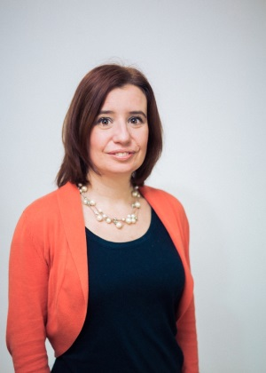
RACHEL McMAHON
General practice is facing unprecedented financial and workload stress, and is battling with a UK government who appears unwilling to negotiate. This pressure is being felt throughout the profession, and for many, sessional working is a positive way of lessening this. I believe this growing choice should be celebrated, and explicitly supported by the profession as a whole.

I strongly believe that the best way to achieve this is by collaborative working across general practice, and throughout the medical profession. We cannot allow ourselves to become an isolated target. We must insist on using the strength of the whole of the BMA to fight threats such as lack of death in service benefits and proposals to impose caps on locum fees.

I have been involved in medical politics for most of my working life, mainly within the BMA itself. I am currently the Vice Chairman of my LMC and a member of the national LMC conference agenda committee. These roles allow me to positively inject the national and regional agendas with a sessional flavour. I am also an active member of the facebook groups Tiko’s, GP Survival and Resilient GP where I often comment on sessional GP issues, as well as working as a GP appraiser.

I have always been strongly spoken, and I believe my passion, knowledge and experience could be a great asset to the sub-committee. Please consider me for a high preference vote.

