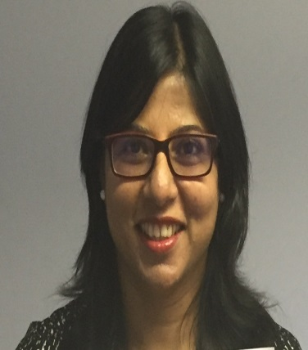

Hi , I have put my name forward for GPC Subcommittee election - northwest in a hope to make a difference-
Campaigning for a 'Blame Free Litigation Free' culture in NHS @drpshukla on Twitter
Key points -
1. Resolving Increasing litigation and indemnity-you may have seen my letter in Pulse 'We need to protect GP's from Litigation. Here’s how.
2. Less onerous appraisal and revalidation system- this infatuation with reflection has to go!
3. National policy to ban OTC drugs on prescription.
4. More representation in CCG and other NHS bodies. Recently had the experience of being excluded from a Senate meeting even though offering to attend in my own time.
5. GPC to become a more active forum with two-way communication through social media rather than a committee meeting in isolation.
Thanks for your support

Preeti Shukla

