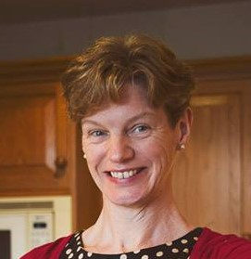

Dr Margaret Lupton

Statement of Experience
I qualified as a GP in 1997 and started work straightaway as a locum from 1997-2001. I set up a local non-principals group as I recognised that working as a locum could be very isolating.
In 2001, I joined a partnership. I was never very interested in the business side of General Practice and I left the partnership in 2010 to help set up a Primary Care-led DVT Service and A&E Diversion Scheme. After being in this role for 18 months I missed ordinary General Practice, so went back to working as a GP locum. In April 2011, I became a Salaried GP and have remained salaried since. I joined the Extensive Care Service in Blackpool, Wyre & Fylde on 4/1/16 as a salaried GP which is a new and challenging role.
In 2008, I was co-opted onto the LMC joining initially as a principal. After leaving my partnership, I changed to become a sessional representative. I regularly attend our local Sessional GPs group which is supported by our LMC.
I was elected onto the BMA Sessional Subcommittee on 1/8/2014 as representative for North West England and subsequently onto GPC as a Sessional Subcommittee representative in August 2015.
I am passionate about providing a voice for sessional GPs both nationally and locally and making sure that we are properly represented. We make up half the GP workforce in many areas now. If elected I will continue to do this, as I believe we have a major role to play in the future of General Practice.

