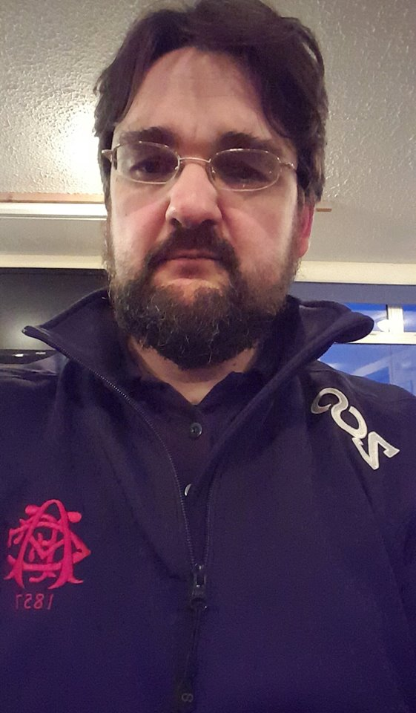

Dr. Andy McIntosh
Region: Scotland

As a grassroots locum/sessional GP and member of GP Survival, I feel passionately about the current situation in general practice. The constant denigration of our profession, underfunding, underresourcing and being taken for granted by successive politicians and by our colleagues in secondary care. I feel particularly strongly about locum and sessional GPs being treated by some as somehow part of the problem. I believe we need a strong voice to challenge this and to ensure that we are treated as equal and valued members of the profession. I chose to be a locum GP as do many of us. I would be a strong voice for both the sessional GP body and also for General practice as a whole. As a Scot, we may not have the same problems as in England but we have our own set of difficulties that need to be robustly challenged. I believe I can do that.
I have asked myself why I would want to be part of the sessional GP subcommittee when I have often felt the BMA to be something of a toothless organisation. I have come to the realisation that to change it, you have to be willing to stand up and be counted. We can change things for the better by providing a strong voice advocating and promoting GP Survival values. It is time for change and I hope to be given the opportunity, along with my GP Survival colleagues, to make this change happen.

