1st October 2015

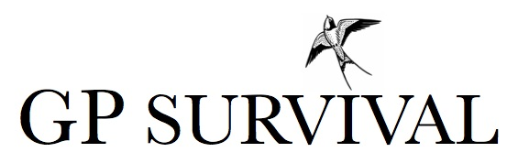

Why is General Practice facing a crisis?

Media outlets are often speaking of a ‘Crisis’ in General Practice. We hope this leaflet explains the challenges facing GPs in the UK, and how these directly affect patients.

A combination of factors has put our family doctors in a really difficult position:

1. Doctor workload has increased by 20% in comparison to 2008 and is still rising. The average Brit sees the doctor six times a year –twice as often as a decade ago.

2. Despite rising workload, the budget for general practice has stayed the same as 2008, and, is likely to decrease over next 5 years. GP practices only get funding for you to visit them twice a year. In fact General Practice only gets 8% of the NHS budget even though 90% of patient contact in the NHS happens in GP surgeries.

3. This leads to shortage of appointments and longer waiting times. Currently almost 11% of patients are unable to get an appointment within two weeks.

4. As a consequence, more people are going straight to A&E for treatment.
This is bad for the NHS budget, as A&E is more expensive – a 10-minute GP consultation costs the NHS £36. But the average cost of an attendance at A&E is more than double that.

5. The increased pressure is leading to burn out in GP's. Doctors are frequently carrying out over sixty 10-minute-consultations a day (plus phone calls, paperwork and home visits to frail elderly and terminally ill patients). We are all aware errors happen when work is too intense.

6. Loss of the GP workforce. In a recent survey 6 out of 10 GPs are considering early retirement and more than a third are actively planning for this decision. With the poor situation in the UK many doctors are leaving the NHS: 5,000 home grown doctors a year consider leaving the NHS to work abroad. Many Australian hospitals are heavily staffed with British doctors.

7. Medical Students and doctors in training don’t want to become GPs There is currently a GP training crisis and in some areas up to 1/3 training posts are unfilled. New contract changes could worsen this situation.

BUT. . . the NHS is still one of the best health care systems in the world, and one of the few totally free ones. In order to protect our NHS please support your GP at this very difficult time.

Please see our website for ways to help.

For further information please contact campaigngpsurvival@gmail.com https://twitter.com/cgps_gp Swallow image used with permission © haveagander.biz

